Appendix
Additional Tables and Figures

Item Wording
Existing measures of SVP use focus either on overall use or on a single dimension. Despite their conciseness, these items lack important differentiating variation that the multi-dimensional novel measures collect. Table A1 lists a few relevant measures of TikTok use as an example.
Table A1: Existing Measures of Short Video Use
Item Wording | Response Options
How often, if ever, do you use the TikTok app? (Marquette Law School 2025) | - Several times a day  - Several times a week  - A few times a month  - Used in the past but not now  - Never
(Now for each of the following, please tell me whether that applies or doesn’t apply to you personally)...You use TikTok once a day or more often. (NBC News 2024) | - Applies  - Doesn’t apply
[Asked only of those who reported using TikTok] (Thinking about the sites or apps you use, about how often do you visit or use)...TikTok? (Pew Research Center, 2024) | - Almost constantly  - Several times a day  - About once a day  - Several times a week  - Less often
(Have you done any of the following in the last month, or not?)...Watched short-form videos (e.g., TikTok, YouTube) (Ipsos 2024a) | - Yes  - No
(On average, how much time per day do you spend consuming the following types of entertainment? Please enter the time in minutes, so if your average time is one hour spent on that activity, type in 60, if it is two hours, type in 120, and so on. Your best guess is fine.)...Watched short-form videos (e.g., TikTok, YouTube) (Ipsos 2024b).

The novel items outlined in Table 1 in the main manuscript are more appropriate for SVP research. They capture important variation in user behavior and attentiveness. In the approach, all respondents are asked to indicate which platforms they used in the past year. Follow-up batteries are used to assess the specific dimensions of use. Respondent burden is minimized with a follow-up for respondents who use four or more social media. Respondents are shown a total of no more than 23 follow-up items, prioritizing data collection for the three platforms they use the most and SVPs.

Table A2: Novel Multi-Dimensional Social Media Use Items
Item Wording | Response Options
Which social media platforms have you used in the past year? Using a social media platform can include simply browsing, posting, or creating content. | - Facebook  - X (Twitter)  - Instagram  - Reddit  - YouTube  - Snapchat  - TikTok  - Pinterest  - Threads  - LinkedIn  - None of the above
Which of the following best describes how frequently you open/visit [Platform] during a typical week? | - I open it more than once a day  - I open it once a day  - I open it a few times a week  - I open it once a week  - I open it a few times a month  - I open it once a month
Which of the following best describes how frequently you open/visit [Platform] during a typical day? [Additional follow-up if the respondent indicates using the platform more than once a day.] | - I open it multiple times an hour  - I open it about once an hour¹  - I open it every few hours  - I let many hours pass between opening the platform
Thinking about a typical experience, when you open or visit [Platform], approximately how long, on average, do you feel you spend on the platform, per use? | - 1 ½ hours +¹  - 1 hour to 1 ½ hours¹  - 46 minutes to 1 hour¹  - 31 to 45 minutes  - 16 to 30 minutes  - 5 to 15 minutes  - Less than 5 minutes

Table A3 details the comparison measures used in the survey experiment to ensure that the novel items did not lack accuracy relative to existing practice.

Table A3: Comparison Self-Report Social Media Measures
Treatment  Name | Item Wording | Response Options
ANES Measure | How often do you use [Platform]? | - Many times every day  - A few times every day  - About once a day  - A few times each week  - Once or twice a month  - Less than once a month
Existing Best Practice (EBP)  Measure | In the past week, on average, approximately how much time PER DAY have you spent ac-  tively using [Platform]? (Ernala et al. 2020) | - Less than 10 minutes per day  - 10-30 minutes per day  - 31-60 minutes per day  - 1-2 hours per day  - 2-3 hours per day  - More than 3 hours per day

Translating Measure to Value
The total amount of time a respondent spent on a platform according to their iOS Screen Time report was divided by their self-reported frequency to compute an average value for each duration answer choice. The reverse was computed for frequency. There were insufficient respondents on the high end of duration, so these answer choices were consolidated in a 46+ minute group. Additionally, the original calculation finds that more than once and hour and once an hour, despite both having sufficient sample size, were not differentiating behavior. These values were also consolidated based on the evidence that they were not measuring different patterns. The final coding translating each response option to a weekly amount is displayed in Tables A4 and
A5.
Table A4: Descriptives of the Frequency Responses: N = Number of Respondents, Avg. Weekly Value = the average frequency of use per week based on Screen Time data, and Coded Value = the quantitative frequency per week described in the answer choice
.
Frequency Selection | N | Avg. Weekly Value | Coded Value
Monthly | 66 | 0.56 | .25
A few times a month | 63 | 0.72 | 1.75
Weekly | 56 | 1.95 | 1
A few times a week | 110 | 7.44 | 3.5
Daily | 100 | 10.30 | 7
Many hours between use | 33 | 18.27 | 14
A few hours between use | 125 | 35.59 | 28
Once an hour + | 154 | 51.58 | 56

Table A5: Descriptives of the Duration Responses: N = Number of Respondents, Avg. Weekly Value = the average duration of use per week based on Screen Time data, and Coded Value = the quantitative duration per week described in the answer choice.

Duration Selection | N | Avg. Weekly Value | Coded Value
Less than 5 minutes | 198 | 6.72 | 2.5
5 to 15 minutes | 304 | 11.44 | 10
16 to 30 minutes | 116 | 22.66 | 23
31 to 45 minutes | 59 | 18.50 | 38
46 + minutes | 30 | 41.29 | 53

Models: Predictors of SVP Use and Accuracy
To explore demographic trends among users of SVPs, a logistic regression model is used to associations with the likelihood of using at least one SVP. Age has the clearest relationship with being an SVP user with older respondents significantly less likely to use the platform than respondents who are 18-29. Among those aged 18 to 29, 95% of social media users in this study report using at least one SVP. This compares with 82% of those aged 30-44 using SVPs, 73% of those aged 45-60, and only 58% of those over the age of 60 using these platforms. Additionally, women are significantly more likely to be SVP users than men. 88% of women social media users reported using at least one SVP compared to 78% of men social media users. 79% of non-Hispanic white respondents report using an SVP compared to 95% of Black respondents and 96% of Hispanic respondents. This may be due to a larger proportion of younger non-white respondents.
There is not statistically significant relationship between income or education and SVP use. Notably, partisans are significantly more likely to use at least one SVP than non-partisans. While Democrats (87%) and Republicans (86%) are statistically indistinguishable from one-another, only 77% of those who identify as Independent or Something Else use SVPs. Overall, the relationships between SVP user and these important populations highlights the need to better understand and assess use of these platforms.
Self-report absolute errors are the absolute value of self-reported weekly total minus the iOS Screen Time weekly total. Under-reporting error occur only when the tracking data indicate greater platform use than the self-reported use. For instances where the respondent reported correctly or over-reported, their error is coded as missing and for instances where the respondent under-reported, the under-reporting error is set to the absolute value of self-reported weekly total minus the iOS Screen Time weekly total. Contrastingly, over-reporting error occurs only when the tracking data indicate less platform use than the self-reported use items. For over-reporting error, where respondents under-reported or correctly reported their time overall, their error is coded as missing and for instances where the respondent over-reported, the error is set to the absolute value of self-reported weekly total minus the iOS Screen Time weekly total.
To analyze the relationship between platform and individual characteristics a linear mixed-effects model is used. Fixed effects are used to predict error as a function of both individual-level characteristics (treatment assignment, gender, etc.) and platform characteristics (the platforms themselves, SVP versus non-SVP). Random effects are used to control respondent repetition, treating each platform they use as a unique case. The fixed-effects portion of the model is depicted in Table A7. While there is some variation by treatment and other demographic traits, the largest predictor of error consistently is the log of total weekly use, based on the self-reported time respondents indicated spending online. Similar to existing measures, the greater the amount of time a respondent reports spending on the platform, the greater their error in reporting their time on the platform.
The Existing Best Practice measure is associated with a reduction in overall error and under-reporting error, however, compared to the novel items, it is associated with greater over-reporting error. Additionally, the ANES item is associated with slightly reduced overall error compared to the novel items. While platform classification (as an SVP or not) is not predictive of overall error, it is associated with slightly less overreporting error and slightly higher under-reporting error compared to non-SVPs.
Additionally, consistent with other research, there is evidence that some demographics are associated with reporting error. Women are more likely to have reduced error compared to men in all three models. Meanwhile, respondents aged 45 - 60 and non-white respondents have higher reporting error across all three models compared to respondents aged 18 - 30 and white respondents.
Respondents with some college, a bachelor’s degree, or an advanced degree and employed respondents are likely to have slightly higher reporting error overall compared to those a high school degree or less and the retired/unemployed, but there is no specific relationships for under- or over- reporting error for these groups. Partisans are more likely to over-report their time online and less likely to under-report their social media use, however, there is no relationship between being a partisan and overall reporting error. Finally, compared to those who report using social media less than people they know, respondents who report using social media more are likely to have higher overall and over-reporting error.

Multi-Dimensional Testing: T-Tests and Clusters
Two one-sided t-tests are conducted on respondents’ average SVP and non-SVP frequency and duration based on the hypothesis that respondents will have greater frequency and duration for SVPs. Both tests are significant (see Figure 1), indicating that users spend both more time on SVPs per use and have more frequent platform engagements.

Figure 1: Comparing Average Frequency and Duration Across Platform Types
(a) Average weekly frequency of short video and non-short (b) Average duration per use of short video and non-short video platforms. p indicates one-sided t-test testing if SVP video platforms. p indicates one-sided t-test testing if SVP frequency is greater than non-SVP frequency. duration is greater than non-SVP duration.

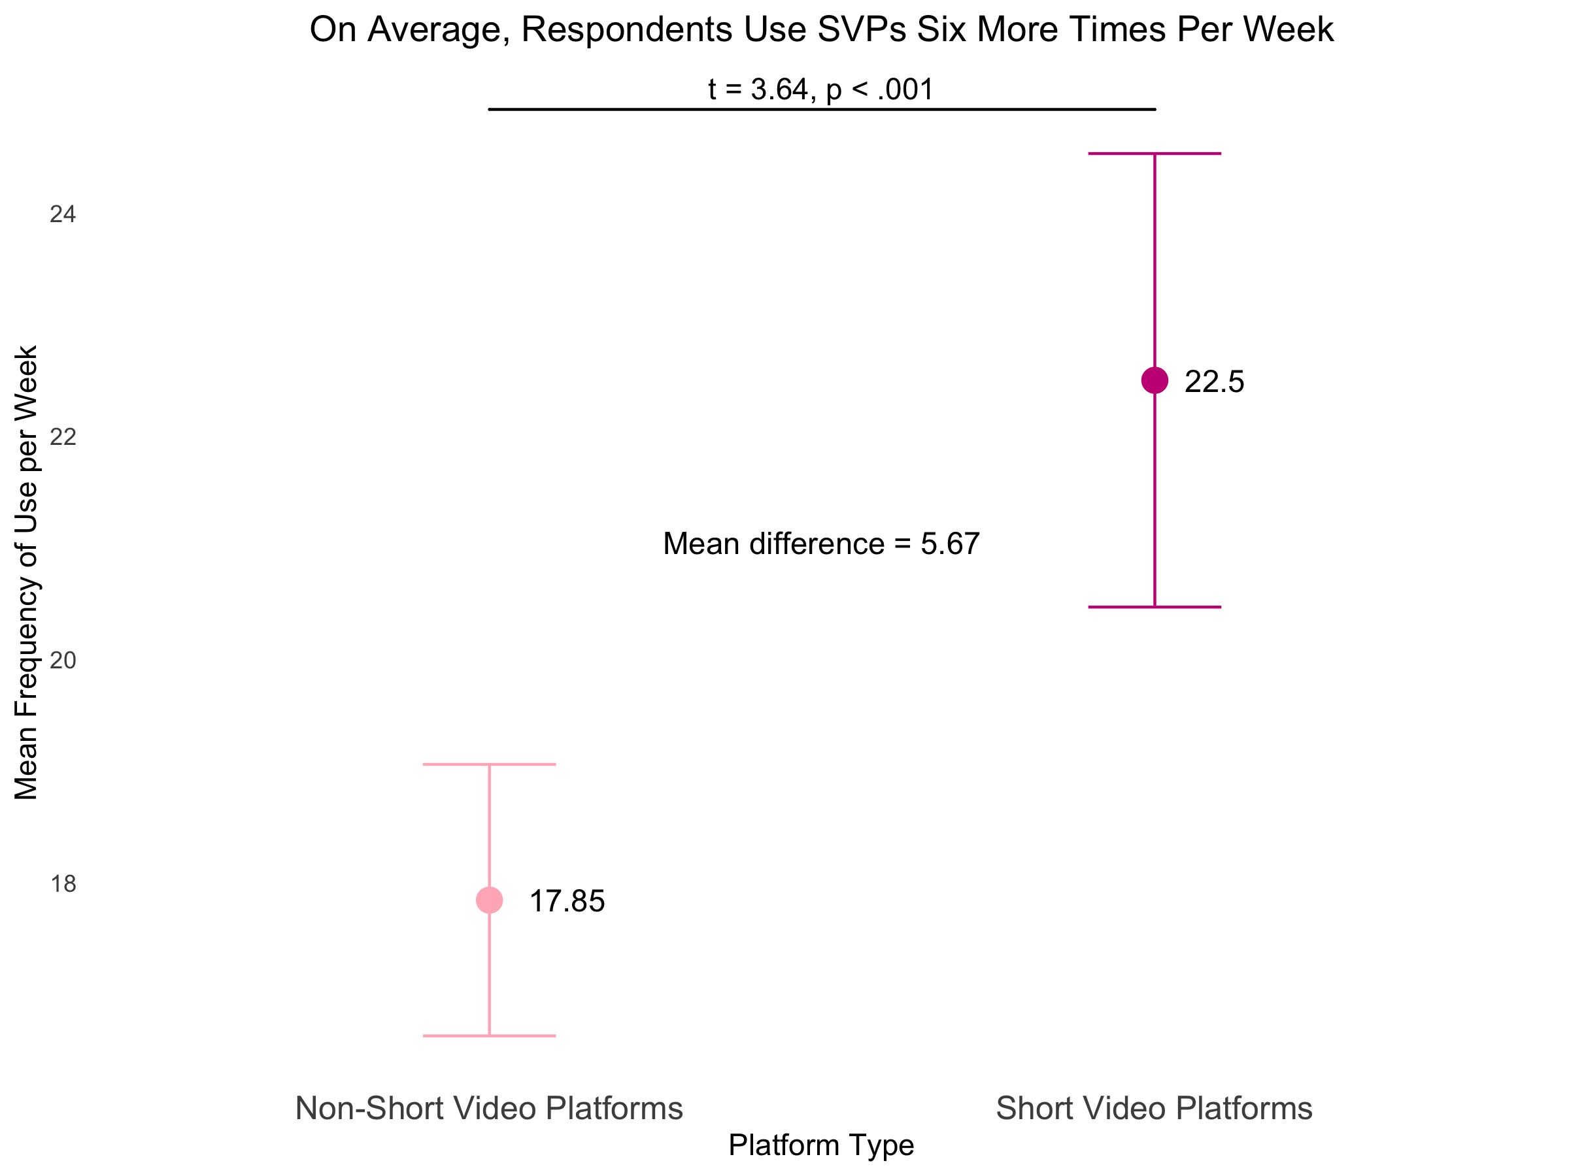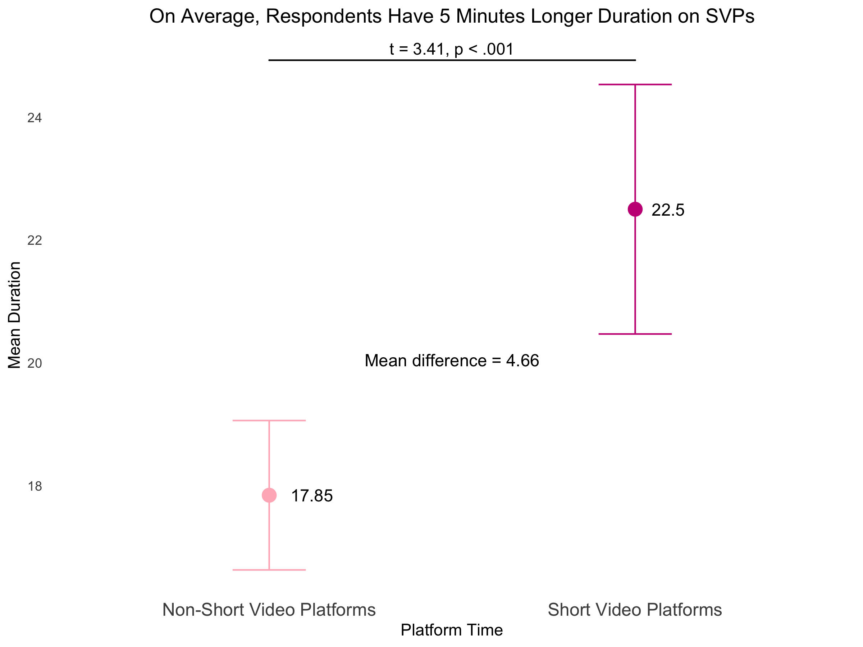

To conduct the cluster analysis, the data are converted so each user-platform pair is a unique case, resulting in a total 1,133 cases (229 individual users) and I analyze use patterns using a clustering approach. Gower Distance is used to compute the distance of all cases from each other. I then apply Ward’s method for Hierarchical clustering to minimize the differences within each group (Alby 2022; Everitt 2011). I find six clusters balance theoretical usefulness and statistical appropriateness, with a silhouette width of 0.48.
The cluster analysis reveals that each of the six clusters have distinct patterns of use based on variation in both use frequency and duration. Rather than being limited to an analysis of simply high and low users, the novel items suggest some users have low duration but moderate or even high frequency. While other uses are characterized entirely by their extremely high duration. Table A8 details the n-sizes and most common responses for each cluster. Figure 2 provides a visualization of the proportion of respondents in each cluster providing each combination of answer choice. Three clusters emerge among low-duration users, there are three distinct groupings of frequency within these. Particularly high duration users span the frequency distribution, but among those with moderate to high duration, users are clustered around being constantly online and regularly online.
Table A8: Description of Clusters: n-size and most frequent response option per cluster.
Cluster | N | Most Common Frequency of Use | Most Common Duration of Use
Low Freq and Duration | 171 | A few times a month | Less than 5 minutes
High Freq, Low Dur | 225 | Once an hour + | 5 to 15 minutes
High Freq, Moderate to High Dur | 171 | Once an hour + | 16 to 30 minutes
Moderate Freq, Low Dur | 302 | A few times a week | 5 to 15 minutes
Extremely High Dur Users | 161 | Daily | 46 minutes +
Moderate Freq, Moderate Dur | 103 | A few times a week | 16 to 30 minutes

Figure 2: Full depiction of the proportion of respondents within each cluster using reporting frequency and duration option.

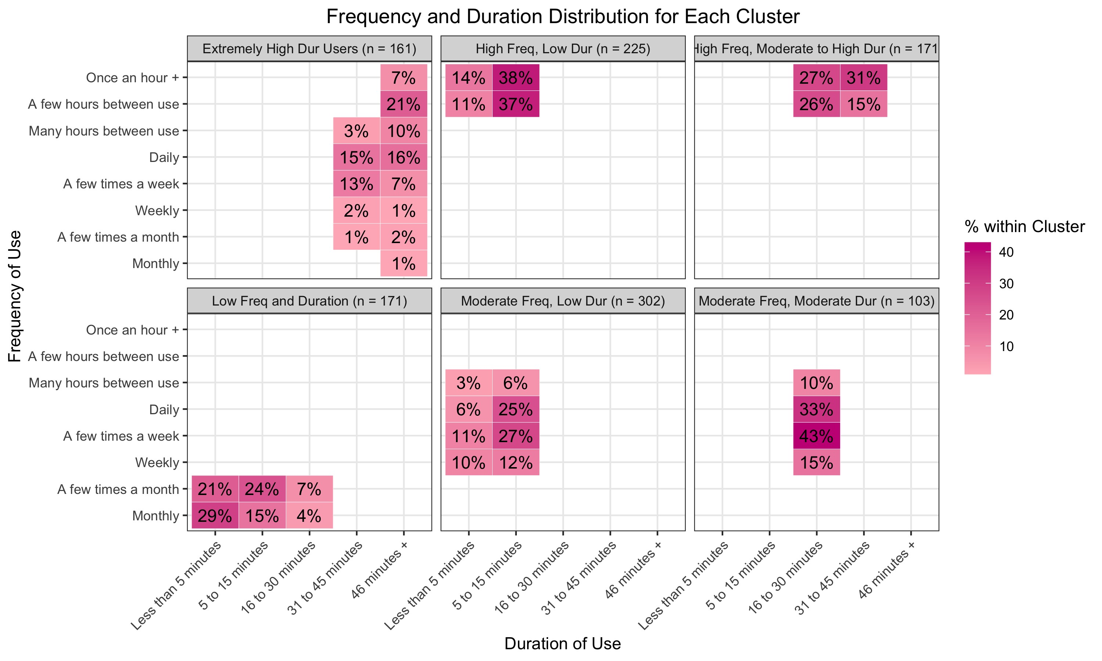
A chi-square test is used to compare the proportions of SVPs and non-SVPs in each cluster and test if there is a relationship between SVPs and cluster assignment. The analysis finds a χ = 43.56 (df = 5, p < .001),
indicating a significant pattern. The residuals (Figure 3) indicate SVPs are more likely to be classified into the High Frequency, High Duration and Extremely High Duration clusters. SVPs are significantly less likely to be classified as Low Frequency, Low Duration and Moderate Frequency, Low Duration users, emphasizing that SVP engagement likely involves extended duration.

Figure 3: Chi-Square Residuals Comparing SVPs and non-SVPs Among Clusters
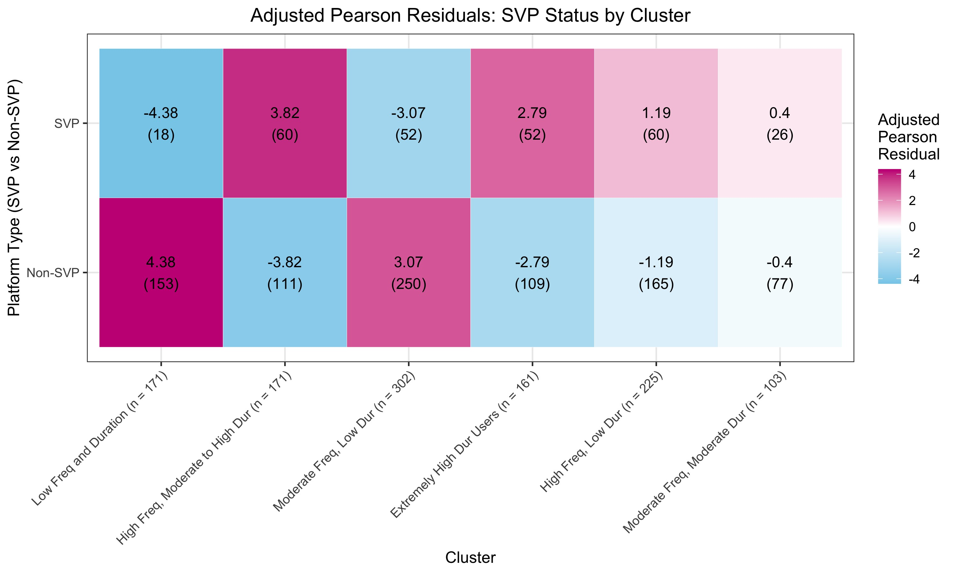

Cognitive Interview Sample
The cognitive interviews were administered October 31, 2024 - December 11, 2024. Using five different guide iterations which tested variations in item wording and iteratively adapted prompts, a total of n = 15 interviews were completed, with saturation occurring around interview 13. N = 9 respondents were undergraduate students, n = 4 respondents were male, n = 1 respondents were non-white, and n = 3 respondents were over the age of 30.

The survey data suggested consolidation of these answer choices. The survey analysis was conducted with these options consolidated and I suggest consolidating them in future use of this battery. For a full translation of these answer choices to values and time please see Tables A4 and A5.

