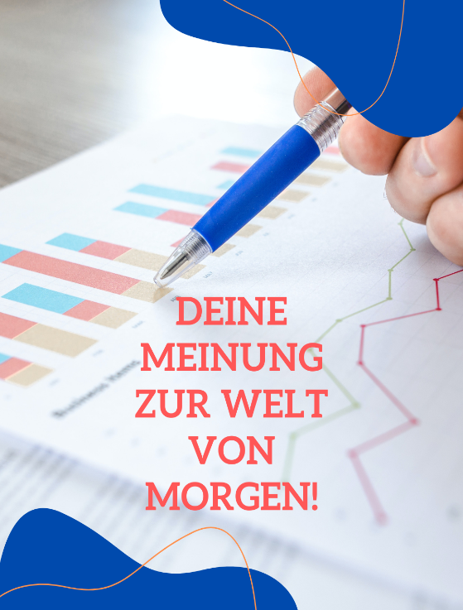
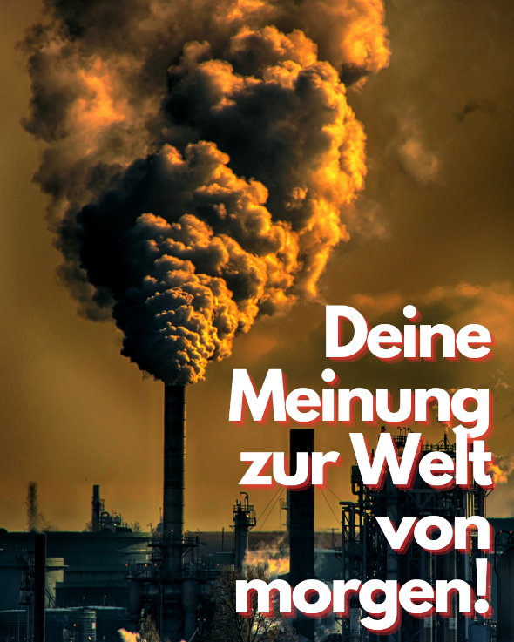
Appendix: Advertising images of this study
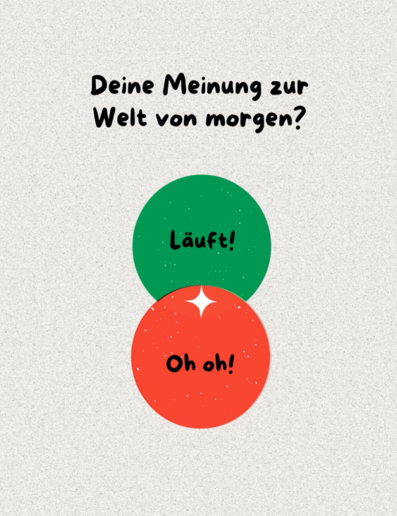

Picture 1 - Climate Picture 2 - Science
Picture 3 – Politics (animated) Picture 4 - Neutral (animated)
Note: Pictures 3 and 4 were animated advertising images. In the case of picture 3, the text flew into the image from below. In picture 4, the two circles switched places and colors with each other. The advertisement text read “Deine Meinung zur Welt von morgen” (“Your opinion on the world of tomorrow”). The call-to-action displayed in the ad was “Nimm an unserer Studie teil” (“Participate in our study”).

